**STUDENT ACTIVITIES SECTION**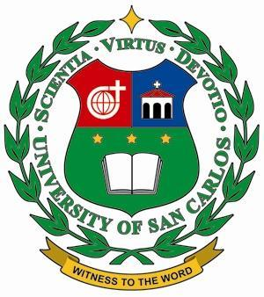

**PARENT’S PERMIT**

**ACA – OSA – SAO - 04F**

Office of Student Formation and Activities

University of San Carlos

Cebu City

January 13, 2023

*(Date)*

Dear _Ms. Blasminda Mayol and Mr. Ean Velayo_

*(Faculty – Adviser)*

We, the parents/ guardians of Christian Stewart allow our child to join the *CISCO Council Photoshoot*  on *January 28, 2023, 10:00 am - 3:00 pm*  at *One Fine Pictures, Robinsons Galleria, Cebu City_*.

We are conscious of the risk and benefits involved in this activity and thus our child, after having obtained our permission has the responsibility of safeguarding himself. We understand that the University of San Carlos and the Office of Student Formation and Activities will not be accountable for any untoward incident that may happen to him/her.

Sincerely yours,

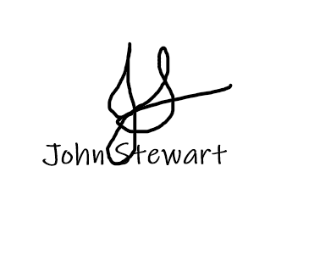

__________________________

Name & Signature of

Parent/Guardian